**Clipping Circuit**

It is in fact a wave shaping circuit, which can control the shape of the output waveform by eliminating or clipping a part of applied wave. This is done without distorting the other (remaining) part of waveform.  
The **clipping circuit** does not have energy storage elements (capacitors) but it includes both linear (Resistors) and nonlinear elements (transistors or junction diodes). This circuit is normally used for the selection in the transmission purpose. In transmission, a portion of a signal wave form occupied below or above a particular reference voltage level is selected. Other than the name – Clipping circuits; Slicers, Clippers, Limiters or Amplitude selectors are also often used.

## **Classification of Clipping Circuit**

* According to nonlinear devices used –
  1. Diode Clippers.
  2. Transistor Clippers.
* According to biasing –
  1. Unbiased Clippers.
  2. Biased Clippers.
* According to configuration used –
  1. Series diode clippers.
  2. Shunt or Parallel diode clippers.
  3. A series combination of reference supply, resistor and diode.
  4. Multi-diode clippers comprise of a number of diodes, resistors and reference voltage.
  5. Two emitter-coupled transistors functioning as an over driven difference amplifier.
* According to level of clipping –
  1. Positive clippers.
  2. Biased clippers.
  3. Negative clippers.
  4. Combination clippers.

### **Diode Clippers**

At least two components – an ideal diode and resistor are employed for the formation of these clippers. In some cases; for fixing the clipping level, a DC battery is also used (Figure 1). When the circuit is forward biased, the ideal diode used operates as a closed switch. When the circuit is reversed biased, the ideal diode used operates as an open switch. Here; by altering the voltage of the battery and by exchanging the position of the various elements, the input waveform can be clipped.

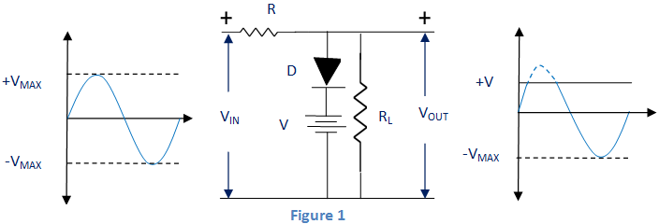

### **Positive and Negative Clippers**

**Positive clippers:**

It actually removes the positive half cycles of the input voltage. Here in positive series clipper, when the input is positive then the diode is in reverse biased condition (output is zero) and when the input is negative, then the diode is in forward biased condition (figure 2).

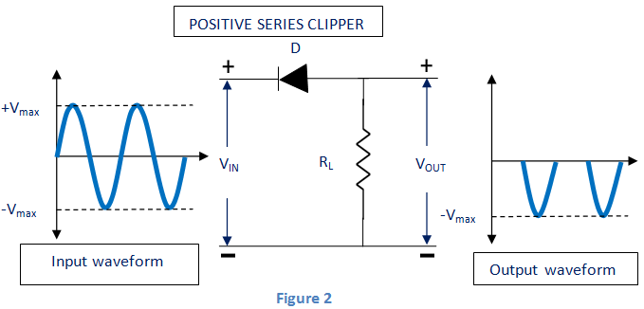

In positive shunt clipper, when the input is negative, the whole input voltage appears across the resistor RL or diode (if R<<rL).

When R<<rL, this circuit will operates as voltage divider and its output voltage is

https://www.electrical4u.com/images/september16/1482402009.PNG

(figure 3).

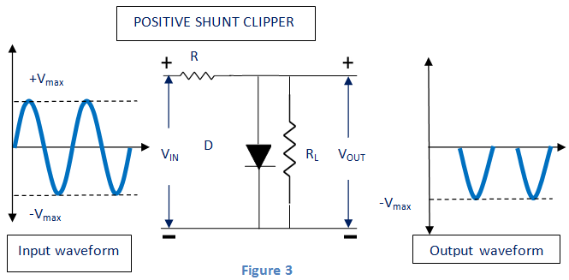

When the diode is connected in reverse polarity in the circuits of positive series clipper and positive shunt clipper, it becomes negative series clipper and negative shunt clipper respectively (figures 4 and 5). These clippers can eliminate the entire negative half cycle of input voltage

.  
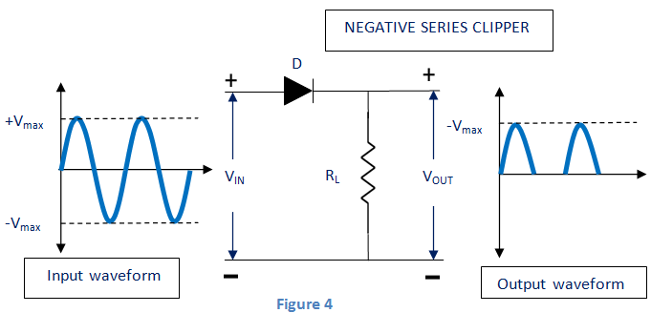  
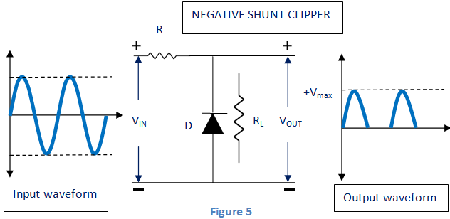The clippers discussed above are considered as the circuits with ideal diode. But if the barrier potential (V0) is considered (Si = 0.7 V and Ge = 0.3 V), the output voltage of positive and negative clippers are shown below.  
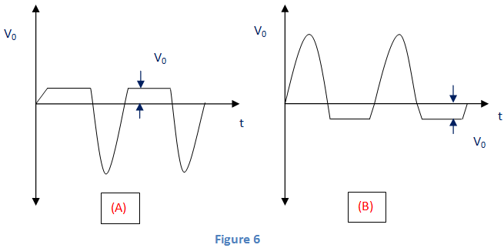

### **Biased Clippers**

In some cases, we need to eliminate a tiny portion of positive or negative half cycles of the input signal voltage. In that case we use biased clippers.  
While during the negative half cycle of input signal in biased negative clipper circuit, it removes the input signal voltage when it is greater than the battery voltage. When the battery and diode is reversed, the clipping can be changed to biased positive clipper (Figure 7).

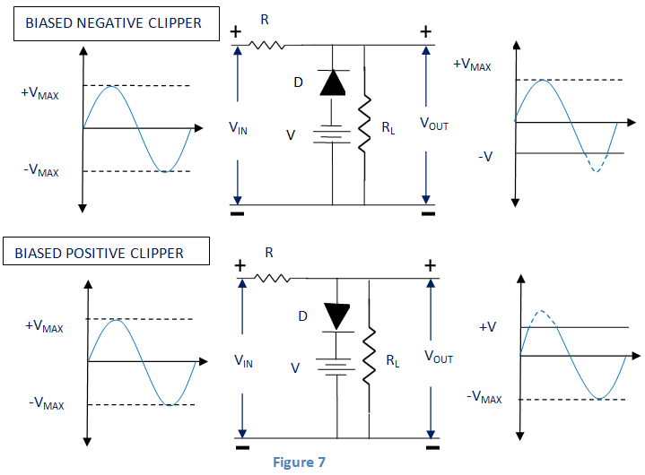

### **Combination Clipper**

For removing a portion of both positive and negative half cycle of input signal, we use this combination clipper (figure below).

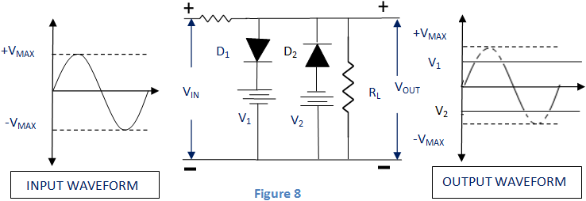

### **Zener Diode as a Peak Clipper**

Zener diodes can be employed for removing (clipping off) the portion of input waveform in the wave shaping circuit (see figure below).  
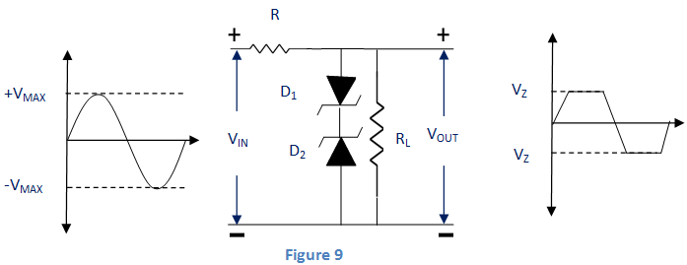

## **Applications of Clipper**

* TV Transmitters and Receivers.
* Noise Limiters.
* Protection of different circuits.
* Different wave generation.