**Clamping Circuit**

The circuit which can set the positive or negative peak of the input AC signal at a required level is what we call as a clamping circuit. This circuit quickly adds or subtracts a DC element to the input AC signal. Other than the name **clamping circuit**, Baseline Stabilizer or DC Reinserted or Level Shifter or D.C Restorer are also frequently used.

The requirement of **clamper circuit** is similar to in TV receivers; where the signal moves through the capacitive coupling network, then the dc component of these signal will get lost. This DC component (not exactly same as that of the lost one) will get restored using this clamping circuit. This circuit will add the DC element which will be positive or negative to the AC input signal. It pushes the signal towards the positive or the negative side (shown below). Here; when it shifts the signal to upward side or positive side, both negative peak and the zero level will meet which is called positive clamper circuit.

When it shifts the signal to the downside or negative side, both positive peak and the zero level will meet which we refer as the negative clamper circuit.

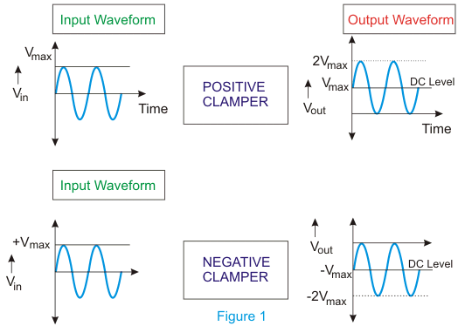

The minimum number of components of a **clamping circuit** is three – a capacitor, a resistor and a diode. In some cases, DC supply is also needed to give an additional shift. The nature of the waveform remains alike, but the difference is in the shifted level. The peak to peak value of the waveform will never change.

The peak value and average value of the input waveform and the clamped output will be different. The time constant of the circuit (RC) must have to be ten times the time-period of the entering (input) AC voltage for better clamping action.

Now, we can assume a negative clamper shown in figure 2. Throughout the positive half cycle of input, the D diode will conduct, and the output voltage will be same as barrier potential of the diode (V0). At that time, the capacitor will get charged to (V – V0). Throughout the negative half cycle of input, the diode will become negative biased, and it has no role on capacitor voltage. The capacitor cannot discharge a lot because of the high value of R. Therefore output voltage will be – (2V- V0). The peak to peak voltage will be 2V. The output waveform that we get will be the original signal shifted in the downward direction.

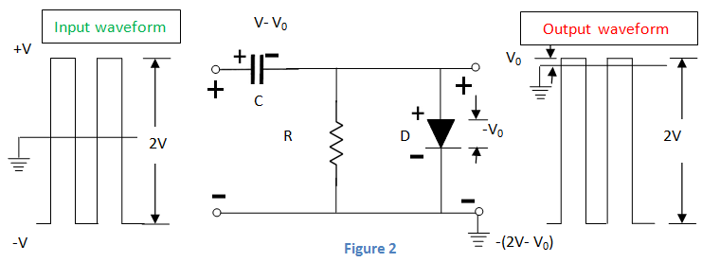

Next, we can assume a positive clamper shown in figure 3. The one and only distinction from the previous circuit is that diode is in reverse polarity. So the output will be the shifted original signal in the upward direction.  
The explanation and working are same as above clamper circuit. Thus we can conclude that we obtain the positive clamper if the diode in the circuit points the upward direction and we get negative clamper when the diode points in the downward direction.

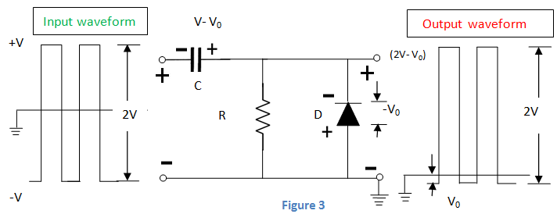

## **Principle of Operation of Clamping Circuit**

In general, the clamper circuit depends on a variation in the capacitor time constant

https://www.electrical4u.com/images/september16/1483183524.PNG

The time constant should be sufficient that the capacitor voltage does not discharge considerably throughout the non-conducting diode period. One should select the values of capacitance and resistance in such a way that the circuit keeps the time constant high. For preventing quick the discharge of capacitor, the resistance value should be high. All through the diode conducting period, the capacitor charging should be very fast. For this, we select a small value of capacitance.

The C in the positive clamper charges quickly throughout the first negative phase of AC input voltage. When Vin becomes +ve, the C serves as a voltage doubler and when Vin is –ve, the C operates as a battery with voltage Vin. Thus, we can conclude that the capacitor and input voltage act against each other. This results in zero net voltage as seen by the load.  
Biased positive clamping circuit and biased negative clamping circuit are shown in figure 4 and 5 respectively.

