**Lecture 6 Design Considerations**

Prior to designing a drip irrigation system, the following informations are needed to be assessed:

• A scaled plan of the site and area to be irrigated.

• Point-of-connection information, including static pressure and available flow.

• Irrigation water type (potable, non-potable, well, etc.) and characteristics

• Soil type (important for determining drip line emitter and line spacing).

• Proposed planting, including relative water needs of all species, and sizes at planting and maturity.

• Local conditions, including elevation differences, local climate data (ETo), and other site specific information.

**6.1     General Considerations**

Several important design criteria affect drip irrigation system efficiency. The most important of these are:

* Efficiency of filtration
* Permissible variations of pressure head
* Base operating pressure to be used
* Degree of control of flow or pressure
* Relationship between discharge and pressure at the pump or hydrant supplying water to the system
* Chemical treatment to dissolve or prevent mineral deposits
* Use of secondary safety screening
* Incorporation of flow monitoring

**6.2     Wetting Pattern**

Drip irrigation systems normally wet only a portion of the horizontal, cross sectional area of soil. The percentage wetted area, Pw compared with the entire cropped area, depends on the volume and rate of discharge at each emission point, spacing of emission points and type of soil being irrigated. The area wetted at each emission point is usually quite small at the soil surface and expands somewhat with depth to form an inverted bulb-shaped cross section. Pw is determined from an estimate of the average area wetted at a depth of 150 to 300 mm beneath the emitters divided by the total cropped area served.

Systems having high Pw provide more stored water. For widely spaced crops, Pw should be held below 67% to keep the strips between rows relatively dry for cultural practices. Low Pwvalues reduce loss of water due to evaporation even where cover crops are used. Furthermore, it is costly to have a low Pwfor more emitters and tubing are required to obtain larger coverage. However, closely spaced crops with rows and emitter laterals spaced less than 1.8m apart, Pwoften approaches 100%.

The area wetted by each emitter, Aw, along a horizontal plane about 30 cm below the soil surface depends on the rate and volume of emitter discharge. It also depends on the texture, structure, slope and horizontal layering of the soil. The Aw values are given in the Table 6.1 for various soil textures, depths and degrees of stratification. They are based on daily or alternate irrigation that apply volumes of water sufficient to slightly exceed the crop water use rate.

On sloping land the wetted pattern may be distorted in the down slope direction. On the steep fields this distortion can be extreme; as much as 90% of the pattern may be on the down slope side. Spray emitters wet a larger surface area than the drip emitters. They are often used in the course textured, homogenous soils where wetting a sufficiently large area would require a large number of drip emitters.

Computing percentage wetted area:

For straight single-lateral systems, the percentage wetted area can be computed as



Where,        Pw = Percentage of soil wetted, %

Np= Number of emitters per tree

Sp x Sr = Plant spacing & row spacing, m

          Se = Spacing between emitters, m

          w = wetted width, m

For spray emitters, the percentage wetted area can be computed as

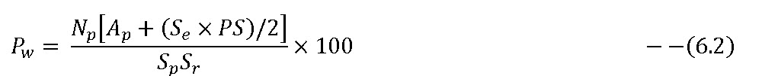

Where,        Pw = Percentage of soil wetted, %

Np= Number of emitters per tree

Sp x Sr = Plant spacing & row spacing, m

          Se = Spacing between emitters, m

          Ap = Soil surface area directly wetted by the sprayers, m2

PS =The perimeter of the area directly wetted by the sprayers, m

**6.3     Irrigation Water Requirement**

The irrigation water requirement for crop production is the amount of water, in addition to rainfall, that must be applied to meet a crop's evapotranspiration needs without significant reduction in yield. The crop water requirements under drip irrigation may be different from crop requirements under surface and sprinkler irrigation primarily because the land area wetted is reduced resulting in less evaporation from the soil surface. Most methods of estimating crop water requirement presently utilized (Doorenbos and Pruitt, 1977) provide estimates of evapotranspiration which probably contain a significant soil evaporation component.

**Table 6.1 Expected maximum diameter of the wetted circle (Aw) formed by a single emission device discharging approximately 4 l/h on various soils.**

|  |  |  |  |
| --- | --- | --- | --- |
| Sand or root depth and soil texture | Homogeneous  (cm) | Varying layers, generally low density  (cm) | Varying layers, generally medium density (cm) |
| Depth 75cm |  | | |
| Coarse | 45 | 75 | 110 |
| Medium | 90 | 120 | 150 |
| Fine | 107 | 150 | 180 |
| Depth 150cm |  | | |
| Coarse | 75 | 140 | 180 |
| Medium | 120 | 215 | 275 |
| Fine | 150 | 200 | 245 |

                    (Source : James, 1998)

**Estimation of evapotranspiration**

Weather parameters, crop characteristics, management and environmental aspects affect evaporation and transpiration. The principal weather parameters affecting evapotranspiration are radiation, air temperature, humidity and wind speed. Several procedures have been developed to assess the evaporation rate from these parameters. The evaporation power of the atmosphere is expressed by the reference crop evapotranspiration (ETo). The reference crop evapotranspiration represents the evapotranspiration from a standardized vegetated surface. The crop type, variety and development stage should be considered when assessing the evapotranspiration from crops grown in large, well-managed fields. Differences in resistance to transpiration, crop height, crop roughness, reflection, ground cover and crop rooting characteristics result in different ET levels in different types of crops under identical environmental conditions. Crop evapotranspiration under standard conditions (ETc) refers to the evaporating demand from crops that are grown in large fields under optimum soil water, excellent management and environmental conditions, and achieve full production under the given climatic conditions.

Factors such as soil salinity, poor land fertility and limited application of fertilizers, the presence of hard or impenetrable soil horizons, the absence of control of diseases and pests and poor soil management may limit the crop development and reduce the evapotranspiration. Other factors to be considered when assessing ET are ground cover, plant density and the soil water content. Cultivation practices and the type of irrigation method can alter the microclimate, affect the crop characteristics or affect the wetting of the soil and crop surface. A windbreak reduces wind velocities and decreases the ET rate of the field directly beyond the barrier. The effect can be significant especially in windy, warm and dry conditions although evapotranspiration from the trees themselves may offset any reduction in the field.

The evapotranspiration rate from a reference surface, not short of water, is called the reference crop evapotranspiration or reference evapotranspiration and is denoted as ETo. The only factors affecting ETo are climatic parameters. Consequently, ETo is a climatic parameter and can be computed from weather data. ETo expresses the evaporating power of the atmosphere at a specific location and time of the year and does not consider the crop characteristics and soil factors. The FAO Penman-Monteith (Allen et al., 1998) method is recommended as the sole method for determining ETo. The method has been selected because it closely approximates grass ETo at the location evaluated, is physically based, and explicitly incorporates both physiological and aerodynamic parameters.

The crop evapotranspiration under standard conditions, denoted as ETc, is the evapotranspiration from disease-free, well-fertilized crops, grown in large fields, under optimum soil water conditions, and achieving full production under the given climatic conditions.

The amount of water required to compensate the evapotranspiration loss from the cropped field is defined as crop water requirement. Although the values for crop evapotranspiration and crop water requirement are identical, crop water requirement refers to the amount of water that needs to be supplied, while crop evapotranspiration refers to the amount of water that is lost through evapotranspiration. The irrigation water requirement basically represents the difference between the crop water requirement and effective precipitation. The irrigation water requirement also includes additional water for leaching of salts and to compensate for non-uniformity of water application.

**Crop coefficient**

Crop evapotranspiration can be calculated from climatic data and by integrating directly the crop resistance, albedo and air resistance factors in the Penman-Monteith approach. As there is still a considerable lack of information for different crops, the Penman-Monteith method is used for the estimation of the standard reference crop to determine its evapotranspiration rate, i.e., ETo. Experimentally determined ratios of ETc/ETo, called crop coefficients (Kc), are used to relate ETc to ETo or ETc = Kc ETo.

The Kc coefficient incorporates crop characteristics and averaged effects of evaporation from the soil. Changes in vegetation and ground cover mean that the crop coefficient Kc varies during the growing period. The trends in Kc during the growing period are represented in the crop coefficient curve. Only three values for Kc are required to describe and construct the crop coefficient curve: those during the initial stage (Kc ini), the mid-season stage (Kc mid) and at the end of the late season stage (Kc end).

The amount of irrigation water requirement was estimated using the crop evapotranspiration (ETc) which was calculated by the FAO Penman–Monteith method ([Allen et al., 1998](http://www.sciencedirect.com/science/article/pii/S0378377404002215#bib3)) based on the climatic data. The FAO Penman–Monteith equation is as follows:

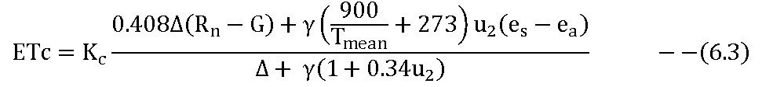

where ETc is crop evapotranspiration under standard condition (mm day−1), Rn net radiation at the crop surface (MJ m−2 day−1), G the soil heat flux density (MJ m−2 day−1) which is relatively small and ignored for day period, Tmean the mean daily air temperature at 2 m height (°C), u2 the wind speed at 2 m height (m s−1) (es − ea) the vapor pressure deficit (kPa), Δ the slope of vapor pressure curve (kPa °C−1), γ the psychrometric constant (kPa °C−1) and Kc the crop coefficient (varies between 0.45 and 1.05) which is affected by several factors such as crop type, crop height, albedo (reflectance) of the crop-soil surface, aerodynamic properties, leaf and stomata properties and crop stages ([Allen et al., 1998](http://www.sciencedirect.com/science/article/pii/S0378377404002215#bib3)).

**Net depth per irrigation**

Normally, drip irrigation wets only part of the soil area. Therefore, the equations for determining the desirable depth or volume of application per irrigation cycle and the maximum irrigation interval must be adjusted accordingly. The maximum net depth per irrigation, dx, is the depth of water that will replace the soil moisture deficit when it is equal to MAD. The dx is computed as a depth over the whole crop area not just the wetted area; however, the percentage area wetted, Pw must be taken into account. Thus for drip irrigation equation can be given as

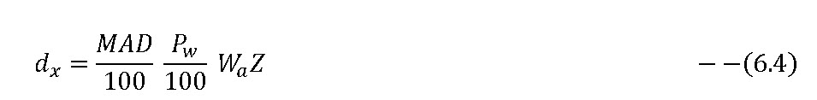

Where

          dx = maximum net depth of water to be applied per irrigation, mm

          MAD = Management allowed deficit, %

          Wa     = available water holding capacity of the soil, mm/m

          Z       = Plant root depth, m

The net depth to be applied per irrigation, dn, to meet consumptive use requirements can be computed by

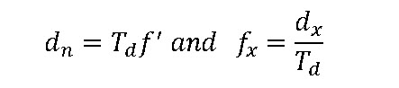Where

          dn= net depth of water to be applied per irrigation to meet  consumptive use requirements, mm

          f’ = irrigation interval or frequency, days

          fx = average daily transpiration during peak-use period, mm

          Td = average daily transpiration during peak-use period, mm

For the design purposes, the Td for the mature crop should be used for sizing the pipe network. Furthermore, assuming irrigation interval as one day, so that dn = Td, simplifies design process (Keller and Bliesner, 1990).

**Gross irrigation requirements**

Gross irrigation depth and volume requirements for drip systems are based on net requirements and efficiencies. The grass depth per irrigation, d, should include sufficient water to allow for unavoidable deep percolation. To minimize avoidable losses, systems should be well designed, accurately scheduled, and carefully maintained. Where LRi ≤ 0.1 or the unavoidable deep percolation is greater than the adjusted leaching water required Tr≥ 0.9/(1.0- LRi) (Keller and Bliesner, 1990).



Where LRi> 0.1 or Tr< 0.9/(1.0- LRi)



Where         d= gross depth of application per irrigation, mm

                   dn= net depth of water to be applied per irrigation to meet consumptive use requirements, mm

                   d' = maximum gross daily irrigation requirement, mm

Tr= peak use period transmission ratio

Td = average daily transpiration during peak-use period, mm  
 Eu = emission uniformity, %

LRi = leaching requirement under drip irrigation

 The gross volume of water required per plant per day, G is a useful design parameter for selecting emitter discharge rates:

G= K d’ Sp Sr

where

G = gross volume of water required per plant or unit length of row per day, L/day

K = Conversion constant, which is 1.0

d’ = maximum gross daily irrigation requirement, mm

Sp = spacing between plants, m

Sr= spacing between row, m

**6.4     Capacity of Drip Irrigation System**

It is necessary to determine the system capacity and operating time per season to design a pumping plant and pipeline network that are economical and efficient. The capacity of the drip irrigation system, Qs is the maximum number of emitters operating at any given time multiplied by average emitter discharge, qa. According to Keller and Bliesner (1990) for uniformly spaced laterals that supply water uniformly spaced emitters

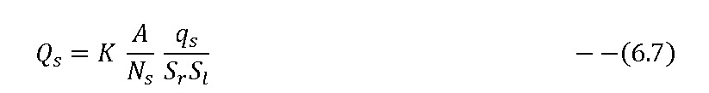

Where,

Qs= Total system capacity, Ls-1qa=Average emitter discharge, L/hr

K= Conversion constant, 2.778                         Se= Emitter spacing, m

A= Field area, ha                                             Sl= Lateral spacing, m

Ns = Number of operating stations

Some systems require extra capacity because of anticipated slow changes in qacan result from such things as slow clogging due to sedimentation in long path emitters or compression of resilient parts in compensating emitters. Both decrease and increase in qanecessitates periodic cleaning or replacement of emitters. To prevent the need for frequent cleaning or replenishment of emitters, where decreasing discharge rates are a potential problem, the system should be designed with 10 to 20 % extra capacity.