**Lecture 19 Fertigation System Design**

In drip irrigation the wetted soil volume is limited, the root system is confined and concentrated. The nutrients from the root zone are depleted quickly, therefore continuous application of nutrients along with the irrigation water is desired.

Factors crucial for effective fertigation design include (i) estimation of available nutrients in soil, (ii) estimation of amount of fertilizer required, (iii) frequency of fertigation, (iv) fertilizer tank capacity, (v) irrigation water requirement, (vi) capacity of drip system, (vii) injection duration, (viii) estimation of concentration of nutrients in irrigation water and (ix) injection rate.

**19.1 Fertigation Parameters**

For the effective fertigation, four criterions must be considered. These items are pedalogical and related with plant as stated below

* the kind of fertilizer required by crop,
* climatic conditions,
* physical and chemical properties of soil,
* exchange capacity of soil.

With fertigation system, the, plant nutrients can be applied alongwith irrigation water in a given interval at required concentration. With this approach, leaching of nutrients especially nitrogen decreases and improves the fertilizer use efficiency. Fertigation reduces fluctuations of soil solution salinity due to fertilizer thereby improving soil solution conditions particularly for salt sensitive crops (Phene and Beale, 1976; Popadopoulos and Eliades, 1987). In general with fertigation, chemical fertilizers can be dissolved and applied for long time on sustainable basis without contaminating soil and water (Source: http://www.iamb.it/par/activities /research/wasia/pdf/theme2\_guidelines.pdf).

**19.2 Estimation of Fertilizer Requirement**

Requirement of fertilizers changes according to the stage of plant growth. The amount of nutrients to be applied during fertigation and the total amount to be applied during active crop production season depend on the frequency of fertigation, soil type, nutrient requirements of the crop and its availability in the soil. Required amount of fertilizer may be estimated by using the following equation

eq_19.1

Where

 Fn= nutrient requirement, kg ha-1

R= recommended dose of fertilizer for the crop, kg ha-1

An= available fertilizer in the soil, kg ha-1

Fcf= fertilizer correction factor (based on factors modifying nutrient requirements i.e. manure, pre-crop residue incorporation, irrigation etc.)

To determine the quantity of fertilizer to be injected into the system for each setting, the area irrigated in each setting of the lateral line is obtained by multiplying the length of the lateral coverage and the move of the lateral. The quantity of fertilizer to be injected is calculated using the following equation

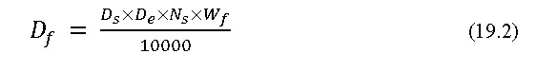

where

Df = amount of fertilizer per setting, kg.

DS = distance between sprinklers, m

De= distance between laterals, m

Ns = number of sprinklers, and

Wf = recommended fertilizer dose, kg ha-1.

**Example 19.1**A lateral has 20 sprinkles spaced 10 meters apart. The laterals are spaced 20 meters on the main line. Determine the amount of fertilizer to be applied at each setting when the recommended fertilizer does is 100 kg ha-1.

**Solution:** Using the Eq. 19.2, Ds = 10 m, De = 20 m, Ns = 20 and Wf = 100 kg ha-1. The quantity of fertilizer to be applied is estimated as

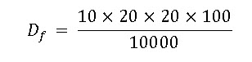

= 40 kg

**19.3 Frequency of Fertigation, Duration and Capacity of Fertilizer Tank**

**a) Frequency of fertigation**

Fertilizers can be injected into the irrigation system at various frequencies once a day or once in every two days or once in a week. The frequency depends on system design, irrigation scheduling, soil type, nutrients requirement of the crop and the farmer’s preference. It is also important to monitor the application of water, as fertilizer application is linked to water application (Locascio and Smajstrla, 1989). In any cases, it is extremely important that the nutrients applied in irrigation are not subject to leaching either during the same irrigation or during subsequent irrigation.

**b) Injection Duration in Fertigation**

The maximum injection duration depends soil type and nutrient and water requirements of the crop. A maximum duration of 45 to 60 minutes (Clark et al., 1990) is generally recommended with enough time for flushing of fertilizer residues from the lines before shutting the pump off. The injection duration is sufficient for uniform distribution of nutrients throughout the fertigation zone. Better to inject for long duration to leave enough time to flush chemicals out of system rather than in a “slug” where highly concentrated solutions of fertilizer usually injected in much less than 45 minutes.

Injection duration is kept within permissible limits to prevent the application of too much water, because excessive water leaches plant nutrients below the root zone. In addition, too much water saturates the soil, causing damage to roots and plants.

**c) Fertilizer Concentration**

The actual concentration of nutrients needed in the irrigation water depends on the type of crop. Many systems will have flowing water with a requirement to maintain a desired concentration of a chemical in the system. This requires injecting a supply mixture at proper rate to maintain the desired concentration level.

According to Howell et al. (1980) fertilizer concentration in the irrigation water is estimated by

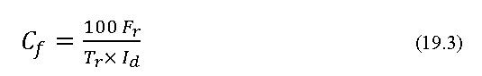

Where,

Cf= concentration of nutrients in irrigation water, ppm

Tr = ratio between fertilization time and irrigation time

Id= gross irrigation depth, mm

Fr = rate of fertilizing irrigation cycle, kg ha-1

**d) Fertilizer Injection Rate**

The fertilizer injection rate into the system depends on the concentration of the liquid fertilizer and the desired quantity of nutrients to be applied during irrigation.

The following equation is used to determine the fertilizer injection rate. The injection rate may be predetermined by the capacity of the injector or the flow rate of the irrigation system.

The desired injection rate can also be calculated by using the following formula if all the parameters are known.

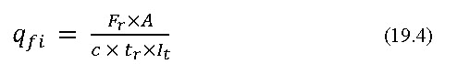

Where, qfi = injection rate of liquid fertilizer solution into the system, L h-1

Fr = rate of fertilizing (quantity of nutrient to be applied) per irrigation   cycle, kg ha-1

A = area irrigated (ha) in time, It

c = concentration of nutrient in liquid fertilizer, kg L-1.

tr = ratio between fertilization time and irrigation time

It = duration of irrigation, h.

Injection time should be limited to prevent over-application of water that will leach chemicals.

**e) Fertilizer Tank Capacity**

The size of the fertilizer tank will depend on the volume of chemical mixture to be injected, which in turn will depend on either the total amount or volume of chemicals to be applied or on the length of the injection period.Low cost tanks are practical where an injection pump or venturi is used. A large tank provides a good place to store fertilizer tank ranges from 30 to 600 L. This is not enough, because some fertilizers need larger, the capacity varies from 300 to 600 L. This is not enough, because some fertilizers need larger quantities because of high application rates or low solubility. The stock solution is prepared based on the solubility of the fertilizers used. Normally highest concentration is not desirable and it is recommended that stock solution is prepared with slightly lesser concentration.

The fertilizer tank capacity is computed by using following equation

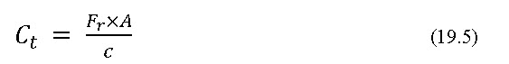

where

          Ct = capacity of fertilizer tank, L

          Fr = rate of fertilizing per irrigation cycle, kg ha-1

          A = area irrigated (ha) in time, It

c = concentration of nutrient in liquid fertilizer, kg L-1.