**Lecture 11 Sprinkler Irrigation**

In this module appraisal of the adoptability, development and use of sprinkler irrigation systems, sprinkler types and components, performance evaluation, design of sprinkler system, maintenance and operation of sprinkler systems have been discussed.

**11.1 Introduction**

In sprinkler method of irrigation, water is sprayed into the air and allowed to fall on the ground surface somewhat resembling rainfall. The spray is developed by the flow of water under pressure through small orifices or nozzles. The pressure is usually obtained by pumping. With careful selection of nozzle sizes, operating pressure and sprinkler spacing the amount of irrigation water required to refill the crop root zone can be applied nearly uniform at the rate to suit the infiltration rate of soil. In sprinkler Irrigation water is applied through a pressurized system. The pressure causes the water to flow out through the sprinkler nozzle. Sprinkler pipe lines are light in weight, hence can be easily transported and installed in the field. They are highly flexible, crack and impact-proof, sustains high pressure and temperature, hence more durable. In this system the water is moved dynamically from the water source through a sprinkler nozzle to a desired height at a high velocity where it breaks up into small droplets and falls on to the soil or crop surface. Due to sprinkling action water wastage is less and it requires less labour than surface irrigation. It can be adapted more easily on sandy soils where infiltration loss is considerably high. Altering the land surface slope for surface methods is always economical.

In sprinkler irrigation water is applied over the crop canopy in form of fine droplets or spray. Sprinkler irrigation keeps soil moisture at its optimum beneficial level giving higher crop yield. Aeration through soil is good so quantity as well as quality of produce is also good. Sprinkler systems have several other uses such as spraying of water for germination, control of soil temperature, control of humidity and frost protection. Several fertilizers and chemicals can be applied quickly and economically.

**11.2 Historical overview**

Agricultural sector is the largest consumer of water. The demand of water has been consistently increasing from various sectors like municipal, industry etc. and each of these can often be at the cost of agricultural requirement. The dominant method of irrigation practiced in large parts of the country is surface irrigation, under which crop utilizes less than one half of the water released and remaining half gets lost in conveyance, application, runoff and evaporation. The drip and sprinklers assume high importance due to high water use efficiency. These methods are to be used for efficient distribution and application of water for crop production.To overcome the problem of water scarcity, the sprinkler system was first introduced in the mid-1950s by few progressive farmers of the Narmada valley in Madhya Pradesh, Southern region of Haryana and north eastern part of Rajasthan and parts of Punjab (Michael, 2010). The adoption of sprinkler system later spread in the states of Maharashtra and Karnataka. It is estimated that About 1,35,000 sprinkler sets were in use in India in 1997 (INCID, 1998). In India, the area irrigated by the sprinkler system is about 3.5 M ha, which is less than 2.5 % of the total area under irrigation. Table 11.1 provides statistics of an area under sprinkler and drip irrigation in different states of India. As on March 31, 2012 Rajasthan has largest area under sprinkler irrigation followed by Haryana. About 65 % of the area under sprinkler irrigation is under field crops likecereals, pulses, oilseeds, cotton, sugarcane and vegetables and the rest 40% under tea, coffee and cardamom plantations in the Western Ghats region and in the North Eastern states. The popularization of sprinkler irrigation in India received significant financial support from centrally sponsored subsidy scheme from the Central Government and partial sharing state governments. In India, per hectare investment for irrigation projects has increased enormously. It is necessary to bring more area under micro irrigation because irrigated farms typically get higher yields and can easily grow 1 to 3 crops per year provided adequate water is available. In view of the scarcity of water and the cost escalation of irrigation projects, it is essential and necessary to economize the use of water and at the same time increase the productivity per unit area. This could be achieved only by large-scale adoption of micro-irrigation system for achieving economy and high crop production. The application of sprinkler and drip irrigation was implemented through National Committee on the use of Plastics in Agriculture under the Ministry of Agriculture Government of India, later it is renamed as the National Committee on Plasticulture Applications in Horticulture. The Committee established twenty two Precision Farming Development Centers in different agro climatic regions of the country for conducting research on micro irrigation and to implement the proven technologies in farmers’ fields through demonstrations.

Experiments conducted in various places of India on different crops under flood irrigation method (FIM) and sprinkler irrigation method (SIM) are grouped in three categories food grains, oilseeds and other crops for the purpose of comparison (Table 11.2, INCID 1998). This can be seen from the results that average increase in yield of various crops varies from 15.09% to 28.9% and saving in water varies from 30.15% to 40.04% over flood irrigation method (FIM) due to sprinkler irrigation method (SIM).

**Table 11.1 Area under Micro Irrigation (Drip & Sprinkler Irrigation)**

|  |  |  |  |  |
| --- | --- | --- | --- | --- |
| **Area as on 31.03.2012 (ha)** | | | | |
| **SN** | **State** | **Drip** | **Sprinkler** | **Total** |
| 1 | Rajasthan | 55715 | 1098133 | 1153848 |
| 2 | Maharashtra | 778660 | 347623 | 1126283 |
| 3 | Andhra pradesh | 665661 | 323457 | 989118 |
| 4 | Karnataka | 293593 | 385675 | 679268 |
| 5 | Haryana | 17772 | 542431 | 560204 |
| 6 | Gujarat | 309520 | 246222 | 555742 |
| 7 | Madhya Pradesh | 110550 | 176223 | 286774 |
| 8 | Tamil Nadu | 206756 | 28217 | 234973 |
| 9 | West Bengal | 589 | 150576 | 151165 |
| 10 | Chhattisgarh | 11328 | 136310 | 147638 |
| 11 | Orissa | 12320 | 46090 | 58410 |
| 12 | Sikkim | 3460 | 2339 | 14799 |
| 13 | Punjab | 27615 | 11559 | 39174 |
| 14 | UP | 13973 | 17328 | 31301 |
| 15 | Kerala | 17301 | 4280 | 21581 |
| 16 | Bihar | 752 | 36628 | 37381 |
| 17 | Nagaland | 0 | 3962 | 3962 |
| 18 | Jharkhand | 1273 | 8842 | 10115 |
| 19 | Goa | 874 | 761 | 1635 |
| 20 | HP | 116 | 581 | 697 |
| 21 | Arunachal Pradesh | 613 | 0 | 613 |
| 22 | Assam | 116 | 129 | 245 |
| 23 | Mizoram | 72 | 106 | 178 |
| 24 | Uttara Khand | 38 | 6 | 44 |
| 25 | Manipur | 30 | 0 | 30 |
| 26 | Others | 15000 | 30000 | 45000 |
| **Grand Total** | | 2543696 | 3597479 | 6150176 |

**Source: NCPAH (2013)**

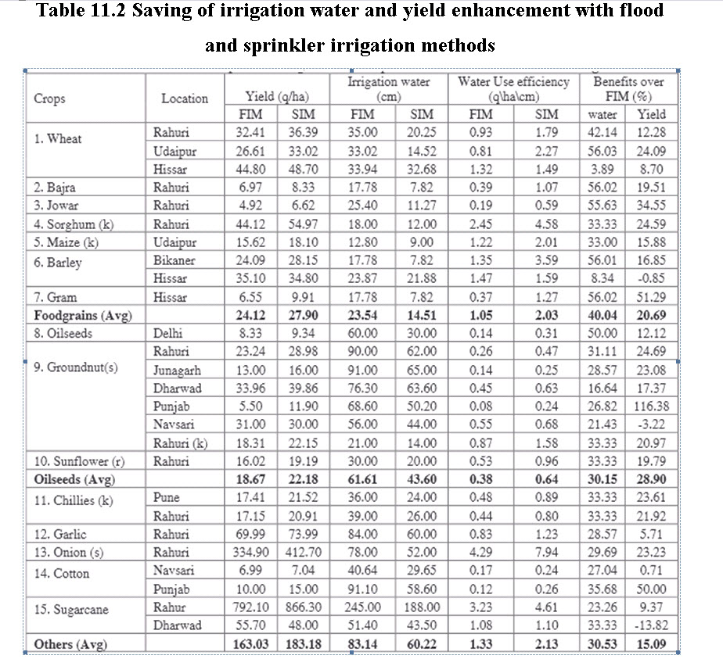

**Source: INCID (1998)**

**11.3 Adoptability and Limitations of Sprinkler Irrigation**

**Adoptability**

i)Suitable to all types of soils except heavy clay.

ii)Suitable for irrigating crops where the plant population per unit area is very high. It is suitable for oil seeds and cereal and vegetable crops.

iii)Water saving & expensive land levelling is not required

iv)Increase in yield. Saves land as no bunds or ridges are required for ponding or guiding water flow.

v)Less problem of clogging of sprinkler nozzles due to sediment laden water as compared to drip irrigation emitters.

vi)Chemical and fertilizer applications can be easily used with sprinkler systems.

vii)Water conservation, saving of labor, fertilizer and pesticides.

viii)Vegetables, citrus, apple, mango, litchi, and other fruit crops can be protected from fog, frost and high solar radiations.

ix)The water use efficiency is high with proper planning and design of sprinkler irrigation systems.

x)Soil moisture can be maintained at optimum level.

xi)Frequent and light irrigation is possible to get better crop response.

**Limitations**

i)High initial investment as compared to surface irrigation methods.

ii)The fine-textured soils which have a low infiltration rate cannot be irrigated efficiently.

iii)Sprinkler irrigation is not feasible in hot climate and high windy areas, as major portion of water is lost through evaporation and water distribution is affected due to high wind speed.

iv)High operational costs due to higher energy requirements.

v) Not suitable for crops that require ponding water. However, research experiments on paddy crops have given promising results.

vi)In humid regions, crops prone to diseases due to moist environment.

vii)Water with impurities and sediments may damage the system.